**PID controller**

**Lab: 10**



Fall 2022

CSE-3L Control Systems

Submitted by: **Amir Suliman**

Registration No: **19PWCSE1805**

Class Section: **B**

“On my honor, as a student of the University of Engineering and Technology, I have neither given nor received unauthorized assistance on this academic work.”

Student Signature: ______________

Submitted to:

**Dr: Muniba Ashfaq**

January 11, 2023

Department of Computer Systems Engineering

University of Engineering and Technology, Peshawar

**Objectives:**

* To know about PID controller.

**Steady Error:**

In control systems, the steady-state error measures how closely a system’s output follows the input after any transients have died out. It is defined as the difference between the desired output and the actual output of a system when the input is constant. There are three types of steady-state error: steady-state error for a step input, steady-state error for a ramp input, and steady-state error for a parabolic input. In general, the steady-state error decreases as the system becomes more accurate and the control system becomes more precise.

**Code:**

|  |
| --- |
| clc  clear  close all;    % Make first system  num = [1];  denum = [1 3 1];  G = tf(num, denum);    % First make negative feedback sytem  Feedback_system = feedback(G,1);    % This is the step rsponse without PID controller  [Feedback_response,t] = step(Feedback_system);      % these are pid coefficients  % changing these values will change the step response  kp = 12;  ki = 999999999999;  kd = -99999999999;    % pid_system = pid(kp, ki, kd);  % now use pidtune  pid_system = pidtune(G,'pid');    % Here G is in series with PID in the forward path  controlled_feedback_system = feedback(G*pid_system,1);    % This is the plot with pid  [Controlled_Feedback_response,t1] = step(controlled_feedback_system);    % Plot the input signal and the system's response  figure  subplot(2,1,1);  plot(t,Feedback_response,'b','LineWidth',2);  xlabel('Time (s)');  ylabel('Amplitude');  title('step rsponse without PID controller');  grid on    subplot(2,1,2);  plot(t1,Controlled_Feedback_response,'r','LineWidth',2);  xlabel('Time (s)');  ylabel('Amplitude');  title('step rsponse with PID controller');  grid on |

**Output:**

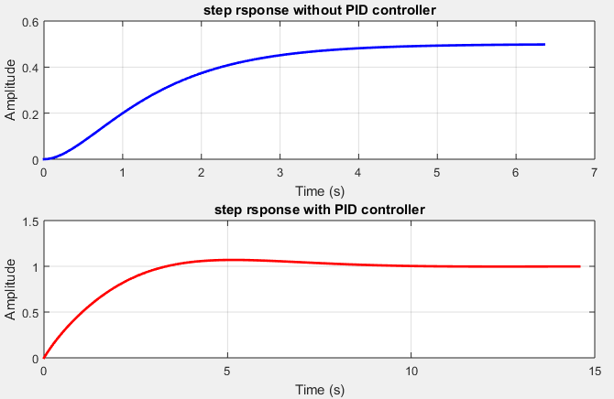

**Simulink Design:**

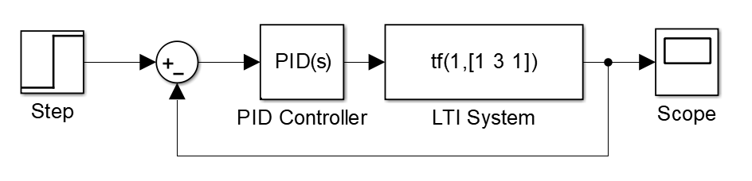

**Code for steady state error using step response:**

|  |
| --- |
| clc;  clear;  close all;    % declaring matrices  A = [1 2; 3 4];  B = [0.4; 0.3];  C = [1 0.4];  D = [0];    % =======================PID Controller====================  % Design observer  L = [-62.0588; 392.6471];  % make a system from num and denum of the observer system  [num,dum] = ss2tf(A-L*C, B, C, 0);  G = tf(num, dum)    % First make negative feedback sytem  Feedback_system = feedback(G,1);    % these are pid coefficients  % changing these values will change the step response  kp = 99999;  ki = 1;  kd = 2;  pid_system = pid(kp, ki, kd);    %pid_system = pidtune(G,'pid');  % Here G is in series with PID in the forward path  controlled_feedback_system = feedback(G*pid_system,1);    % ================ step response of observer state feedback controller ===============  % This is the step rsponse without PID controller  figure  subplot(2,1,1)  [y,t] = step(G);  plot(t,y,'r','Linewidth',3)  title('Step response of observer controller before pid controller')  ylabel('amplituide')  xlabel('Time(s)')  grid on  % This is the step rsponse with PID controller  subplot(2,1,2)  [x,t1] = step(controlled_feedback_system);  plot(t1,x,'b','Linewidth',3)  grid on  title ('step response of observer controller after pid controller')  ylabel('amplituide')  xlabel('Time(s)') |

**Output:**

**PID controller:**

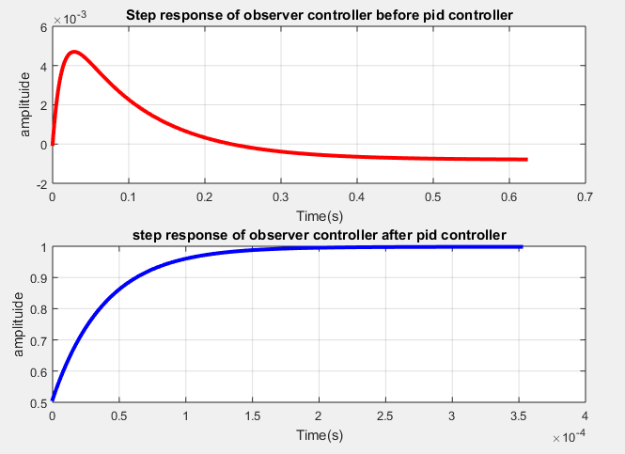

**Simulink Design:**

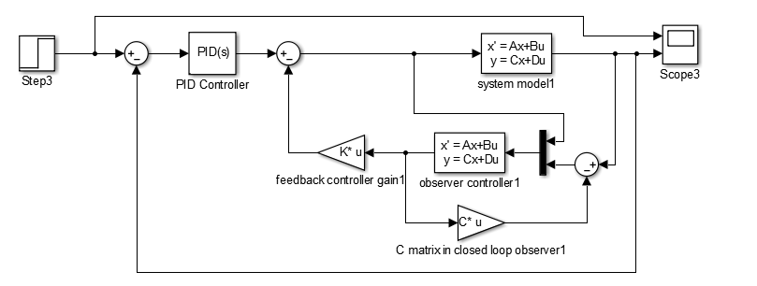

**Code for steady state error using ramp signal:**

|  |
| --- |
| clc;  clear;  close all;    % declaring matrices  A = [1 2; 3 4];  B = [0.4; 0.3];  C = [1 0.4];  D = [0];    % =======================PID Controller====================  % Design observer  L = [-62.0588; 392.6471];  % make a system from num and denum of the observer system  [num,dum] = ss2tf(A-L*C, B, C, 0);  G = tf(num, dum)    % First make negative feedback sytem  Feedback_system = feedback(G,1);    % these are pid coefficients  % changing these values will change the step response  kp = 60993;  ki = -121906;  kd = 200000000;  pid_system = pid(kp, ki, kd);    %pid_system = pidtune(G,'pid');  % Here G is in series with PID in the forward path  controlled_feedback_system = feedback(G*pid_system,1);    % ================observer state feedback controller ramp response===============  % Define the ramp signal  t = (1:1001);  ramp_signal = t;  t1 = (0:0.01:10);  % Simulate the observer state feedback controller response to the ramp reference signal  [ramp_y, t1] = lsim(controlled_feedback_system, ramp_signal, t1);    % Plot the ramp reference signal  figure  subplot(2,1,1)  plot(t1, ramp_signal, 'r','Linewidth',3);  title('ramp reference')  xlabel('Time (s)');  ylabel('Output');  grid on    % Plot the observer controller system response  [ramp_y, t1] = lsim(controlled_feedback_system, ramp_signal, t1);  subplot(2,1,2)  plot(t1, ramp_y, 'b','Linewidth',3);  title('observer controller ramp response after PID controller')  xlabel('Time (s)');  ylabel('Output');  grid on |

**Output:**

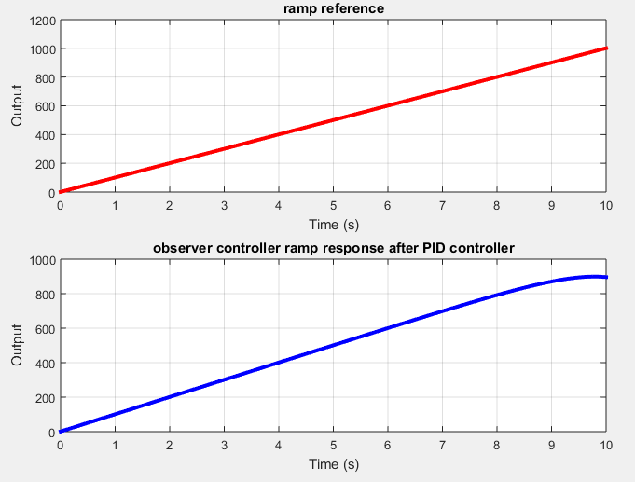

**Simulink Design:**

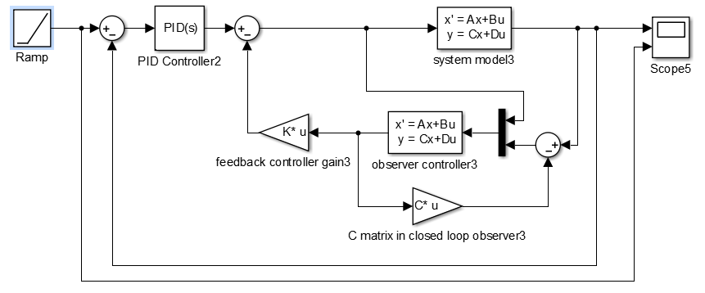

**Code for steady state error using parabola response:**

|  |
| --- |
| clc;  clear;  close all;    % declaring matrices  A = [1 2; 3 4];  B = [0.4; 0.3];  C = [1 0.4];  D = [0];      % =======================PID Controller====================  % Design observer  L = [-62.0588; 392.6471];  % make a system from num and denum of the observer system  [num,dum] = ss2tf(A-L*C, B, C, 0);  G = tf(num, dum)    % First make negative feedback sytem  Feedback_system = feedback(G,1);    % these are pid coefficients  % changing these values will change the step response  kp = 60993;  ki = -121906;  kd = 200000000;  pid_system = pid(kp, ki, kd);    %pid_system = pidtune(G,'pid');  % Here G is in series with PID in the forward path  controlled_feedback_system = feedback(G*pid_system,1);  % ================ Parabolic response of observer state feedback controller ===============  t = 0:0.01:10;  parabola_signal = t.^2;  [Y_parabola,T_parabola] = lsim(controlled_feedback_system,parabola_signal,t);    % Plot the input signal and the system's response  figure  subplot(2,1,1);  plot(t,parabola_signal,'b','LineWidth',2);  xlabel('Time (s)');  ylabel('Amplitude');  title('Parabola signal');  grid on    subplot(2,1,2);  plot(T_parabola,Y_parabola,'r','LineWidth',2);  xlabel('Time (s)');  ylabel('Amplitude');  title('System response');  grid on |

**Output:**

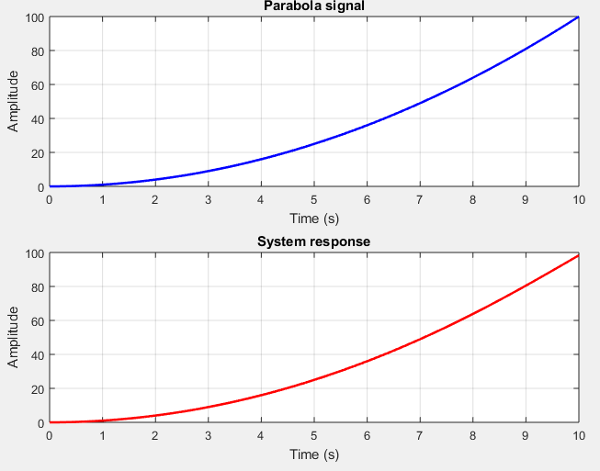

**Simulink Design:**

